July 29, 2014
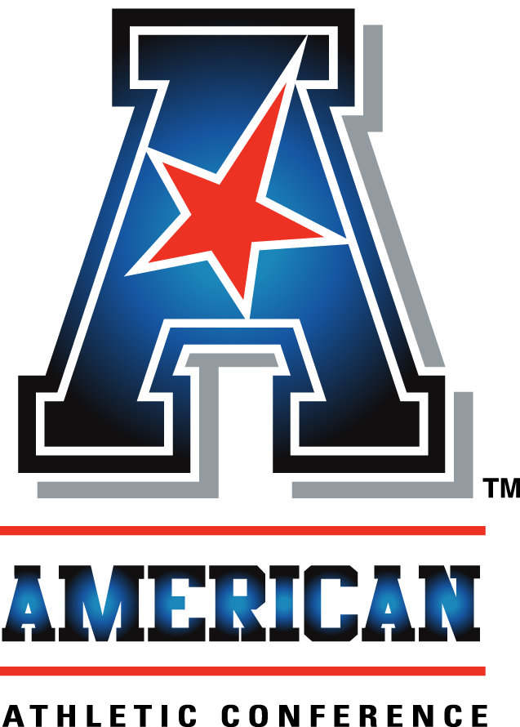
An interview with:

COACH TONY LEVINE

THE MODERATOR: Our next coach is from the University of Houston, Coach Tony Levine, entering into his third year at Houston. Last year eight wins in his season, and a promise for this season.
COACH LEVINE: Again, I'll go ahead and make a statement regarding our program and certainly open it up for questions.
I'm excited to be here. Always exciting. It means the season's right around the corner. We're looking forward to our student-athletes reporting in three days officially. We'll have what we call a family welcome luncheon at noon, which we started a couple years ago, where our student-athletes report and bring their families kind of as a send off. We had around 650 people at that luncheon.
We'll have a team meeting and dinner Friday night. We'll get going Saturday. We have our own Media Day on campus, Fan Appreciation Day, then our first practice, which is open to the public.
We're looking forward to the weekend getting here and getting started officially, if you will.
I'm going to mention a couple things about our football stadium. Certainly excited about it. Be one of the nicest, brand-new stadiums in the country. Our student-athletes are excited, our coaches, our staff, certainly everyone within our program. But as much as anything, we're looking forward to getting back on campus.
Last year was challenging. It's a small price to pay, we mentioned this, to get a beautiful, brand-new football stadium on campus. We played off campus at Reliant Stadium, and then a soccer stadium. I know our student-athletes, alumni and fans are looking forward to being back on Cullen Boulevard to getting back into the stadium.
The schedule as you look at this season is an interesting one. I'll use that word. It's going to be challenging but interesting in the fact for a couple things. We've got three bye weeks the way the calendar falls, and we have eight Saturdays throughout this season that we don't play. We have five midweek games, two on Thursday nights, two on Friday nights.
In terms of scheduling each week, when you practice, how you practice, how you keep the student-athletes fresh with short weeks and certainly longer weeks with the byes, is something we're looking forward to. Again, it's going to be a great challenge.
Talking more extensively about where our program is. For the last two years or so as head coach, I used the word 'young' quite often. Since the end of last season I haven't used that word at all other than to reference the last two years.
It's fun right now coming off an eight-win season, playing in a bowl game in January, to see how much experience we have within our student-athletes returning this year. I think there's a lot to be said certainly about experience, whether it's starting experience or game experience. I feel like in all three phases we definitely have that this year.
Offensively we're going to return a young man at quarterback named John O'Korn. I think what a lot of people don't know maybe nationally, but they know it within Houston, as a junior at St. Thomas Aquinas High School, he was the backup quarterback. He didn't start as quarterback till his senior year in high school. When you look at what he did for us last year, it was his second year as starting quarterback at any level. I think we're going to see growth this year in him.
No pun intended when I talk about growth. The last time everyone saw him play publicly in January in our ballgame, John weighed 196 pounds, last week he weighed in at 225 pounds. He's gained almost 25 pounds of muscle. To be able to go through our strength and conditioning program in the off-season, his first spring practice at the University of Houston, I think it's going to be fun to finally give him the entire offensive playbook and see how he does this season.
We have very talented skilled young men offensively. I think we have great depth at runningback and receiver. I think we have experience up front on the offensive line as well. We have Bryce Redman returning, three-year starter for us at center, and Rowdy Harper, starter for us at guard. Some young men, Alex Cooper, Damien Parris, Emeka Okafor that have been in our program. I think we're going to have great depth there as well.
We have a couple transfers that will be available for us this fall as well. I think offensively we'll continue to see putting points on the board, up tempo, and certainly no-huddle.
Defensively on paper we return nine starters. I think when you look on paper how many starters you've got back, the numbers can be deceiving at times. We lost two senior corners off of last year's team, but we return three or four corners that had significant playing time and experience for us last year.
I think what our staff did defensively last year was outstanding. We went from two years ago, I think 110th in the nation in scoring defense, and last season moved up 90 spots to 20th overall in scoring defense. We led the country in turnovers with 43, and turnover margin we were almost plus two on the year, which was first in the country. Proud how we took the ball away defensively.
Again, having that type of experience back on that side of the ball. This spring, again, it was fun to have that experience and depth, not try to reinvent the wheel in terms of now expanding so much. We wanted to get good at what we do, really focus on our technique as well.
Kicking game, we have everybody back except Richie Leone. Richie I thought was one of the premier punters in all of college last year. He's now with the Baltimore Ravens.
Demarcus Ayers as a true freshman last year was a high school quarterback. The year before moved him to receiver. Taught him how to return kickoffs. He was the conference special teams Player of the Year. He'll return as a sophomore.
Greg Ward, a young man that came in as a quarterback athlete, moved him to receiver. Look for him to have a breakout season this year as a sophomore. Anticipate him being our punt returner.
I think Kyle Bullard is a young man that kicked field goals and extra points for us last year, he'll be a junior. We'll have some competition for the punting position as well.
Our long snapper returns. I don't ever mention his name publicly. Our holder returns, as well.
Again, I like the experience we have across the board in all three phases. Again, the word 'young' you won't see me use that this season. Got great experience and a really good group of student-athletes in that locker room.
Having said all that, I will take any questions.

Q. How difficult was it to play in a different stadium, now you're coming back having your own stadium again?
COACH LEVINE: Well, you know, it was a challenge last year. The thing about last season, we planned for it. We knew it. There was a word I'm not a fan of, the word 'distraction.' You can look at it a couple different ways. We tried to make it into a positive. I think we played a little bit last year with a little bit of a chip on our shoulder coming off the season we had before that.
We felt like in theory while we've got a great fan base, great students, but not playing on campus, it almost felt like, if you will, you're playing mostly away games. Again, our fans showed up. I don't want to have anybody misinterpret what I'm saying. But we were always in a new locker room, taking a bus 10 or 15 minutes.
It will be fun to be back on campus. I think when you talk about distraction of last year, if you will, playing off campus, I think you have to make sure when you're back on campus in a beautiful stadium, it doesn't become a distraction either, especially early.
We're going to get into the stadium in terms of having it turned over to us in the next couple of weeks. We're going to do a good job as a staff and program bringing our student-athletes over there a couple times before the first game to show them this is where we're going to dress, this is where we'll walk, stretch, so the first time they do that is not Friday night, August 29th.

Q. You mentioned you have some stability this year. You're going to have a stadium to call home, returning starters, quarterback. How does that change maybe your approach to the season in terms of what you expect out of your players?
COACH LEVINE: Well, it's a fair question. Until you mention that, I didn't know we had any votes for first or last in our league.
We had a team meeting with our student-athletes a couple weeks ago. There's certainly a lot of excitement nationally for the college football season, regardless of program. This is the time of year where there's a lot of award watch lists and pre-season award lists that come out. A lot of our student-athletes have been on those pre-season lists.
We talked about a number of things in this team meeting. The last thing we discussed was the feeling of what's important to us, if you're looking at individual awards, are the post-season award lists, not the pre-season speculation of what individuals are going to play well, certainly what programs are going to do well.
We don't look at whether we're ranked first pre-season by coaches or media or fans. We don't look if we're not ranked first, ranked lower.
Again, I don't think you define a season by one game ever. We'll literally take one week at a time. We'll look up at some point in December and see how we did, and hopefully we're going to continue to play at that point.
Again, it's fun seeing the experience back, so I don't want to downplay the fact we have some talented young men returning that played significant roles for us. Any sort of pre-season hype or lack thereof within our conference or individually, we don't pay a whole lot of attention to.

Q. You mentioned your takeaways, your defense was one of the best in the country. Things come and go generally speaking statistically. How do you anticipate that working out this year? Was it something you did or was there luck involved in that?
COACH LEVINE: Well, I don't feel like there was a whole lot of luck involved. Again, I understand and agree with what you're saying. At times you can say this year the team had the ball bounce a certain way, and next year they didn't. It's the same team and same coaches.
When we made the change at defensive coordinator a year ago, brought in David Gibbs, the things we wanted to do was reduce our defensive package, if you will, the amount of what we did. We felt like if we could make sure our student-athletes understood what to do, how to line up, what to do when the ball was snapped defensively, have that confidence in their knowledge, if you will, of what we're doing on that side of the ball, then we could focus much, much more on the things we feel could help you win in terms of tackling and taking the football away. That's what we were able to do.
I think our defense became very, very confident over the course of last season. I think they were confident going into the season, but they were still coming off of 110 scoring defense ranking.
We don't feel like that was a fluke last year. Again, we were almost plus two in the turnover margin with the 43, which I think was by far and away number one in the nation. It's something with nine returning starters on paper, as much experience as we have defensively, we're going to aim to do again this season.

Q. You only really had one season to evaluate John O'Korn in high school. I'm sure you established some sort of projection of what you thought he might be as a quarterback in your system. Compare his performance last year to maybe what that projection was and how good he was for you as a true freshman.
COACH LEVINE: I'd like to stand up here and lie to you and tell you we knew exactly what we were getting. We offered John a scholarship his junior year. He had not started a high school football game yet. He committed to us prior to his senior year, which was I think also part of the reason that he came to Houston. We showed faith in him early on. He ended up being the Florida offensive high school Player of the Year, winning a state championship, most valuable player.
Not necessarily this part of my answer talking about John O'Korn, in recruiting it's not an exact science. You try to do a great job evaluating. You certainly try to do a great job building relationships with the young man and their family. Until they get on campus and you're coaching them, I don't think any coach in the country would say, I knew exactly what we were getting in every young man.
In John, we didn't have a whole lot of football footage to go off of, if you will, but we certainly did our research. We, for a number of reasons a couple years ago, took our quarterback recruiting nationally, felt like he was the top quarterback nationally that we were recruiting, although he hadn't played high school football yet.
Again, I think he's got a tremendously high ceiling, if you will. I think it's going to be fun, as I said earlier, to watch him develop as a sophomore, go through our strength and condition programming, a second spring practice in 2015, come back as a junior. The sky's the limit for what he can be, not only on the field, but off the field as well.
Thank you very much.

FastScripts by ASAP Sports

